1. 
2. Producer sends msg to a broker and msg is stored in topic partition.   
   If we have more than one broker and properly configured replica factor, then a partition is copied to other broker as well.
3. 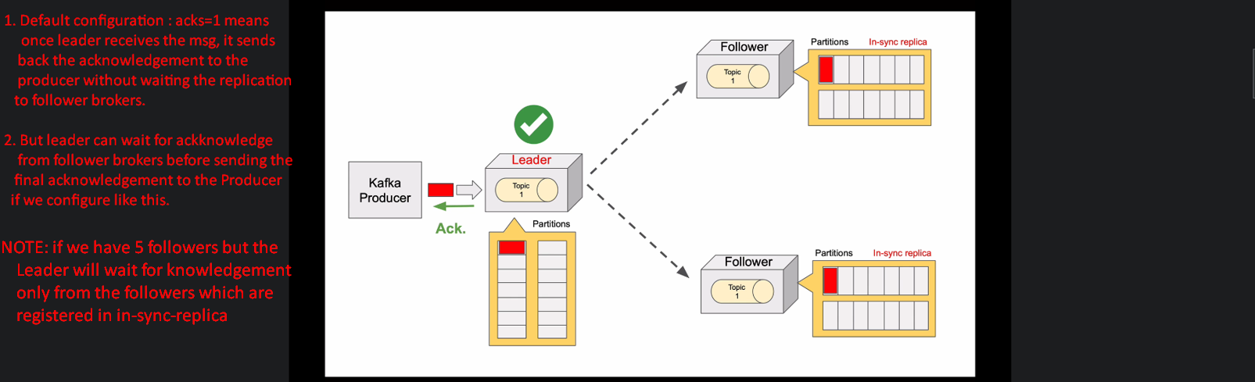
4. If losing msg is okay sometimes, then configure the producer not to wait for acknowledgement at all.
5. 
6. 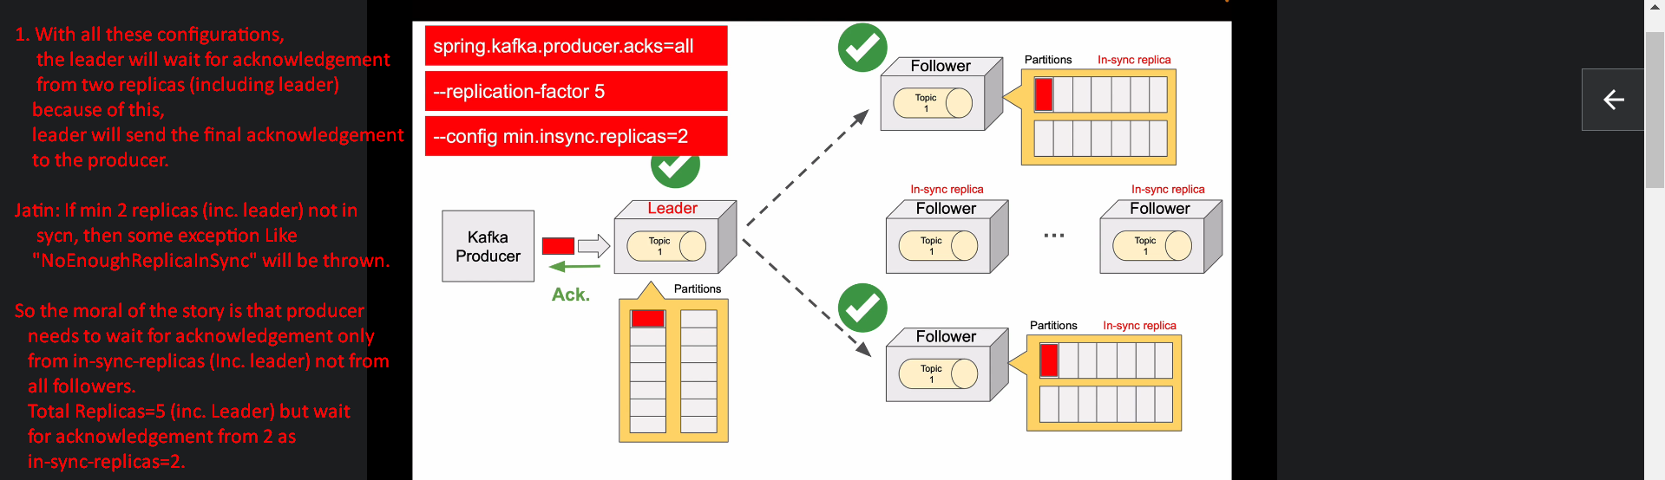
7. 